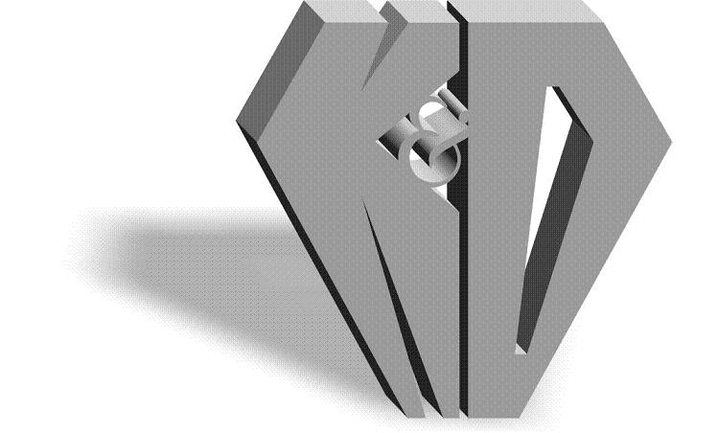
K&D DIAMONDS, INC.

Manufacturers & Importers of Diamonds

36 W 47th St Suite 1006 New York, NY 10036 

Tel: (212) 869-0811  1-877-869-0811  Fax (212) 869-0815

Website: www.kddiamonds.com

CUSTOMER IDENTIFICATION AND VERIFICATION FORM

Registered Name K&D Diamonds Inc

Registered Business Address: 36 W 47 St Suite 1006 , New York, NY 10036

Phone Number 212.869.0811

Fax Number 212.869.0815

E-mail Address Sales@kddiamonds.com

Website Address www.KDDiamonds.com

Federal Tax Identification Number 133872142

Owner of Business: A. Klein, David Dresdner

Sincerely,

Aaron Klein
Compliance Officer
K&D Diamonds Inc.

